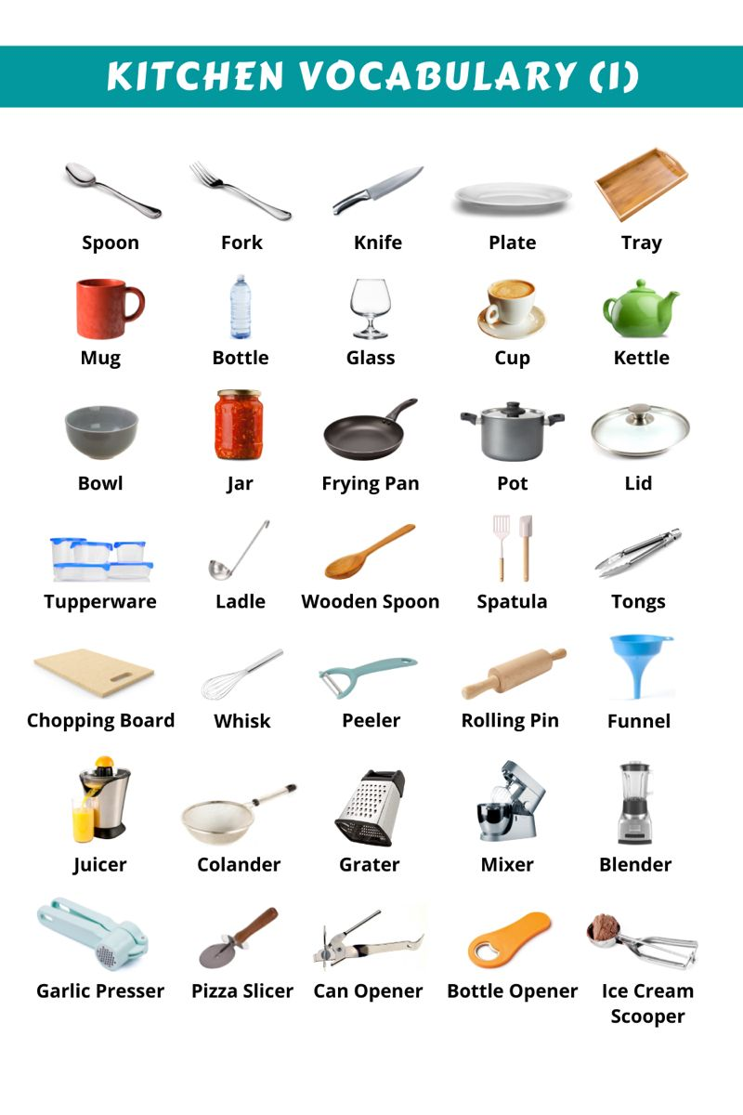
KICHEN ITEMS IMAGES

